Introduction
This document explains how to use 3 different nodes to communicate with a Siemens S7 PLC :
- wiw2ValuesObject used to cast a What Is What message into an object,
- valuesObject2Wiw used to cast an object into a What Is What message,
- valuesObject2S7 used to cast an object into a message compatible with a node-red-contrib-s7’s s7 out node.

The flow
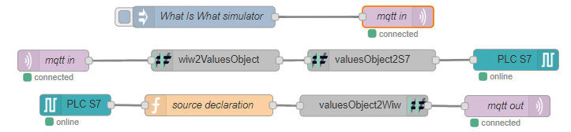
This flow has been created with node v10.16.0 and Node-RED v0.20.7.

Third party dependencies
A Mqtt broker must be running. See mqttBroker document for more information.
To read/write to Siemens S7 PLCs, dedicated nodes are needed. Here we are using: node-red-contrib-s7.
To test this example, we recommend to use a S7 PLC, but a simulator may be good enough. You can find one in Snap7 library, available here https://freefr.dl.sourceforge.net/project/snap7. Snap7 v1.4.1 has been successfully tested.

Explanation
This flow demonstrates how to use the three presented nodes to send and receive values to and from What Is What.

First line
The first line simulates a message from What Is What. It is needed only in this example, and is not relevant in production. The inject node creates a JSON object that could have been sent by What Is What.

Second line
The second line shows the reception of this message from a Mqtt broker. The message is sent to a Wiw2ValuesObject node which will cast it into a new message (see wiw2ValuesObject documentation). Then valuesObject2S7 casts it into a message compatible with S7 node, which writes data onto PLC.

Third line
The third line reads values from PLC. A function node is used to set the wiwSource property to “machinedemo” (the name previously used in the entity declaration, see entities2Wiw example) to indicate to What Is What which entity has to be updated. Then, valuesObject2Wiw node creates a What Is What message to declare the values. This message is sent by Mqtt node.

Note
Please make sure to use the right Mqtt broker settings in the Mqtt client setup.

